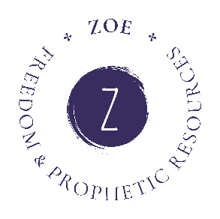
Zoe Freedom & Prophetic Resources - Charity Gift Aid Declaration
Boost your donation by 25p of Gift Aid for every £1 you donate.
Gift Aid is reclaimed by the charity from the tax you pay for the current tax year. Your address is needed to identify you as a current UK taxpayer.
To Gift Aid your donation, please check the box for each option that applies below:
I want to Gift Aid my donation of £ Click or tap here to enter text. to the charity Zoe Freedom & Prophetic Resources

I want to Gift Aid all past and future donations I make/have made to Zoe Freedom & Prophetic Resources

I am a UK taxpayer and understand that if I pay less Income Tax and/or Capital Gains Tax in the current tax year than the amount of Gift Aid claimed on all my donations it is my responsibility to pay any difference.
My Details: (PLEASE COMPLETE)
Title | Click or tap here to enter text.
First name or initials | Click or tap here to enter text.
Surname | Click or tap here to enter text.
Full Home address | Click or tap here to enter text.
Postcode | Click or tap here to enter text.

Please email your completed form to us at info@zoefreedomprophetic.com
Please contact us if you want to:
- want to cancel this declaration
- change your name or home address
- no longer pay sufficient tax on your income and/or capital gains

If you pay Income Tax at the higher or additional rate and want to receive the additional tax relief due to you, you must include all your Gift Aid donations on your Self-Assessment tax return or ask HM Revenue and Customs to adjust your tax code.

